CS170 HW05 –

Lab09 Part I – SwitchErrors

1. Get Scanner class from library.
2. Declare Scanner object and a variable integer – number
3. Show program purpose - show key options 1, 2, 3 with corresponding color and ask for user input.
4. Request user for a type ‘integer’ input.
5. Use switch statement with case 1,2,3 with corresponding color and a default class with no color
6. End program greeting

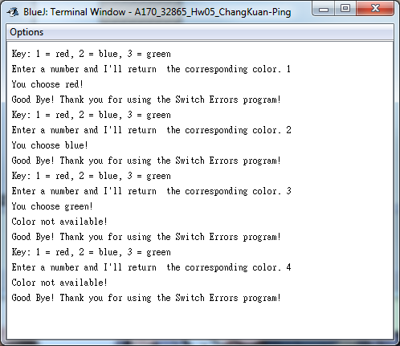

Part 2 – DayName

1. get scanner class from library
2. Declare Scanner object and a variable integer – number
3. Show program purpose - show key options 1 to 7 with corresponding 'Day' of the week and ask for user input.
4. Request user for a type 'integer' input.
5. Use switch statement with case 1 - 7 with corresponding Day Name and a default class with invalid input reply
6. End of program message

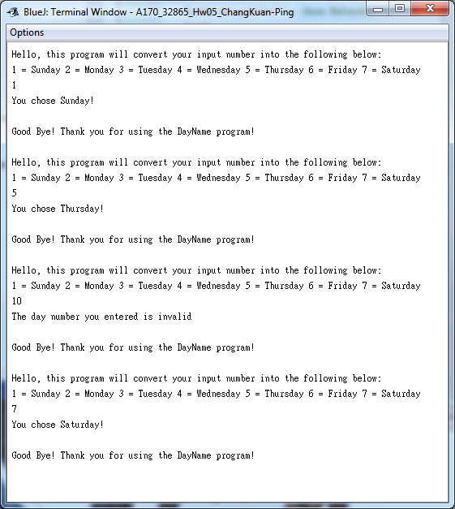

Wk05 HW – Branching & Decisions. MonthNumber

Pesudocode:

1. get scanner class from library
2. Declare Scanner object and two integer variable - year, leapYear, and a String variable - month
3. Show program purpose - Calculate the month number and days of that month in the given year.
4. Prompt for user input and read the next integer value for variable year.
5. Calculate if the year is a leap year - leap year is divisible by 4.
6. Prompt for another user input and read the next string value for variable month.
7. Use switch statement with 12 case with corresponding month and a default class with invalid input reply
8. End of program message

